STORE SALES PREDICTION

WIREFRAME DOCUMENT

KHUSHI KATHURIA

iNeuron

**Homepage**

Homepage consists of single page having different input section and submit button. The page designed in such way that user can inserts their inputs according to their store details. There are 9 input sections in the homepage where the user will have to enter the correct entries as per their bigmart store information.

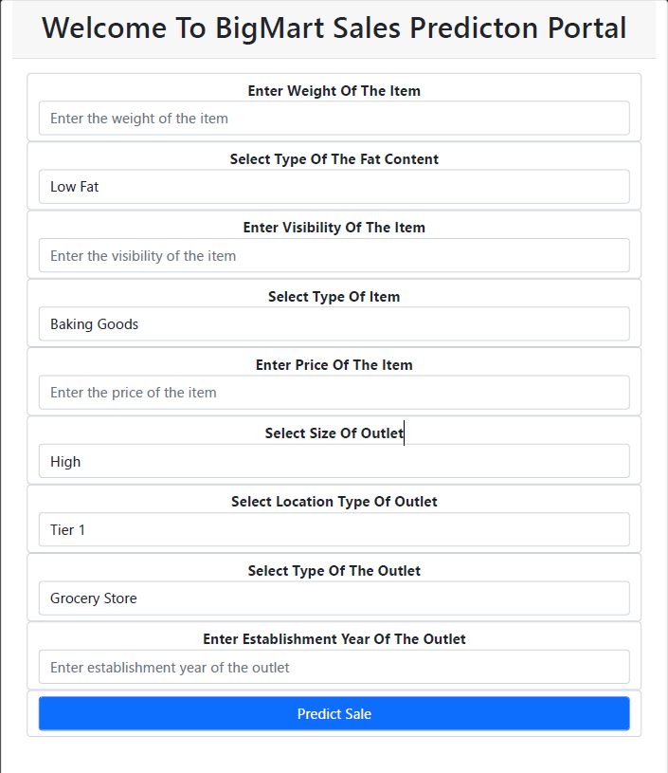

After filling the above information page looks like:

